Date: 13th June 2025

**PRIVATE AND CONFIDENTIAL**

CHRISTIAN ATAM ATAM

No 319 Kawaji Jigirya

Hadejia Road, Kano

Nigeria.

Dear Christian

**TERMS AND SCOPE OF ENGAGEMENT FOR INTERNSHIP AS A DEVELOPER**

I am pleased to extend an offer for the position of an intern Developer with ConnectNigeria. We believe in your skills and creativity, and we are certain you will be a valuable addition to our team.

**Position Details:**

**Title:** Developer

**Start Date**: 16th June2025

**Trial Period:** 1 Month

**Compensation**:

**First Month**: 50,000

**Second Month:** 100,000 (upon successful completion of the trial)

At 6 Months: Up to 150,000 (based on performance)

During the trial period, you will be expected to demonstrate your technical expertise and contribute to ongoing projects. This is a fantastic opportunity to showcase your skills in software development, collaborate with our team, and help us achieve our goals.

**Work Environment**:

You will join a dynamic and innovative team that values collaboration, creativity, and continuous learning. We believe in fostering an environment where your ideas and contributions can shine.

**Confidentiality:**

You are mandated to maintain absolute confidentiality with respect to any confidential information received from the Company. You shall not disclose any such information without obtaining specific prior written consent from the Company’s Managing Director or authorized representative. Furthermore, this agreement is subject to the terms of the Non-Disclosure and Confidentiality Agreement attached.

Please confirm your acceptance of this offer by Monday the 16th of June once you accept, we can arrange an onboarding session to discuss your role, responsibilities, and the exciting projects you will be working on.

**TERMINATION**

Either party may terminate this agreement by giving 1 month written notice to the other party. The obligation of the parties shall continue during the notice period.

If you are prepared to accept the terms of this contract, kindly submit the following documents alongside a signed copy of this contract:

* Copy of your passport photo
* 2 Referees
* Document indicating your bank details to enable payment of your fees

We look forward to receiving your acceptance of this engagement and to working with you.

Yours faithfully,

Name: Cynthia Jaiyesimi

**Human Capital Manager**

I agree to the terms of engagement contained herein 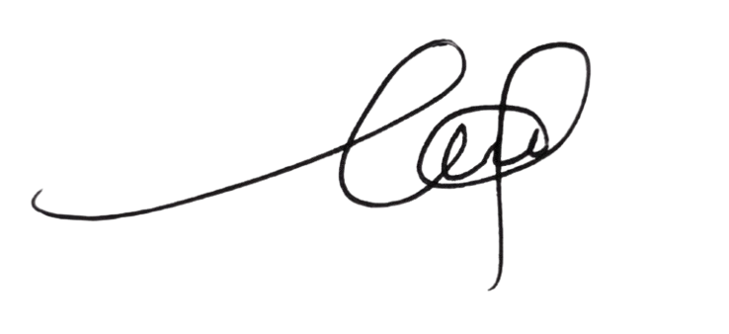

___________________________________

**Name: Christian Atam**

Date: 15th June 2025